Ideation Phase
Define the Problem Statements

Date | 28 November 2025
Team ID
Project Name | Flight Booking App
Maximum Marks | 2 Marks

Customer Problem Statement :

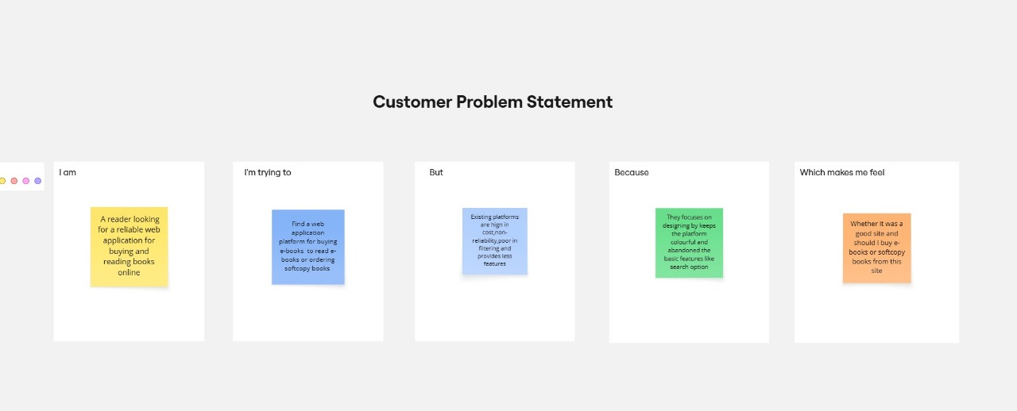

Problem Statement (PS) | I am (Customer) | I'm trying to | But | Because | Which makes me feel
PS-1 | Frequent traveler | Book flights quickly and conveniently | Existing platforms show irrelevant flights or poor UX | No effective route/date filtering or search | Wasted time, frustration, missed deals
PS-2 | Flight operator | Manage my flights and bookings efficiently | Need admin approval before accessing the dashboard | No operator management system exists | Stuck in waiting, loss of potential revenue
PS-3 | Airline administrator | Oversee all operations (users, flights, bookings | No centralized oversight or control panel | Scattered systems without unified dashboard | Stuck in waiting, loss of potential revenue

